## [Facade]條件欄位後端繁簡轉換查詢

Shared by: Gilbert Lin

Problem:

頁面欄位輸入繁體無法查出簡體資料

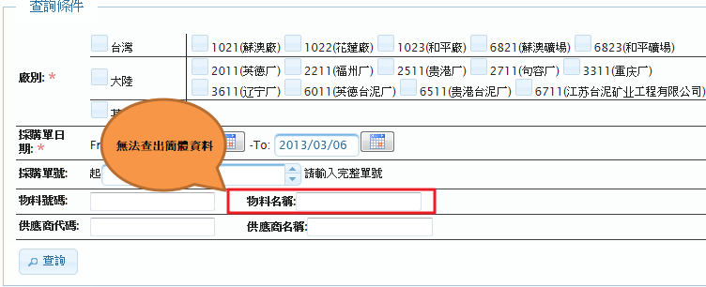

**Solution:**

利用 zhcoder.java取得簡繁體陣列組出where 條件SQL

**SQLUtils.java(詳細程式碼請看**Ref.**)**

/**

* 繁簡轉換SQL

* and (f2.description like #materialName1 or f2.description like #materialName2)

* @param columnName

* @param value

* @return

*/

public static String getLikeTranslateSQL(String columnName, String value){

StringBuilder sb = new StringBuilder();

if(StringUtils.isBlank(value)){

return sb.toString();

}

sb.append("and (");

String[] values =converterZhCode(value);//取得繁體及簡體字串

int i = 0;

for (String value_l : values) {

if(i!=0){

sb.append(" or ");

}

sb.append(columnName);

sb.append(" like ");

sb.append("'");

sb.append(likeFilter(value_l));

sb.append("'");

i++;

}

sb.append(") ");

return sb.toString();

}

**usage**

**TcZtabExpEkkoFacade.java**

//料號名稱(繁簡查詢)

String matnrNm = StringUtils.trim(condVO.getMatnrNm());

if (StringUtils.isNotBlank(matnrNm)) {

queryString.append(SQLUtils.getLikeTranslateSQL(" AND ekpo.TXZ01", matnrNm));//料號名稱

}

Ref.

com.tcci.pp.facade.util



com.tcci.pp.util.zhcoder

